**LAB 2 REPORT**

**Name : Heena Agarwal**

**Student id : 113061327**

**● The data set I have chosen is ​Disabled population in India​.**

**● The data set has 19 columns and 400 rows.**

**● The link from where I have chosen the data set is** [**https://www.kaggle.com/kumareshbabuns/india-disabled-population**](https://www.kaggle.com/kumareshbabuns/india-disabled-population)

**● The link of the video explaining the implementation : ​** <https://youtu.be/7vHKHnHGfe4>

**● I have used python for backend and used flask for connecting my backend and front end d3.js version 3 for this assignment.**

**DATA CLUSTERING AND DECIMATION**

**TASK-1 implement random sampling and stratified sampling (remove 50-75% of data)**

**For Random sampling:**

rs_data_frame=scaled_df.sample(frac=0.50)

**For Stratified Sampling:**

**In adaptive sampling, the total samples are divided into clusters. Then sample is taken from each group. To determine the k-means clustering, I have plotted k elbow chart as shown below and we can see that k = 3.**

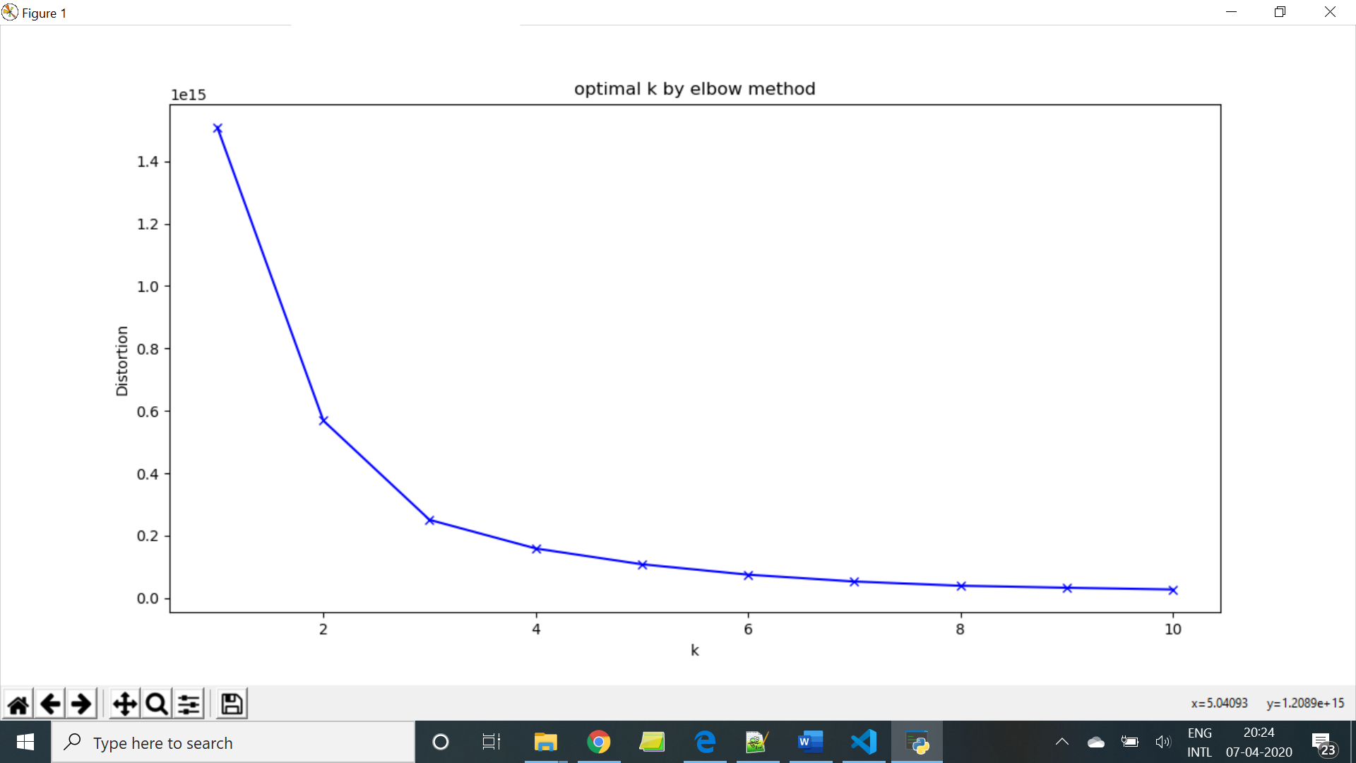

**Task 2: dimension reduction on both org and 2 types of reduced data**

1. **find the intrinsic dimensionality of the data using PCA**

**We can see that intrinsic dimensionality of data is somewhere between 5 and 10.**

pca = PCA()

    pca.fit(scaled_df)

    eigen_vectors=pca.components_

    eigen_values=pca.explained_variance_ratio_

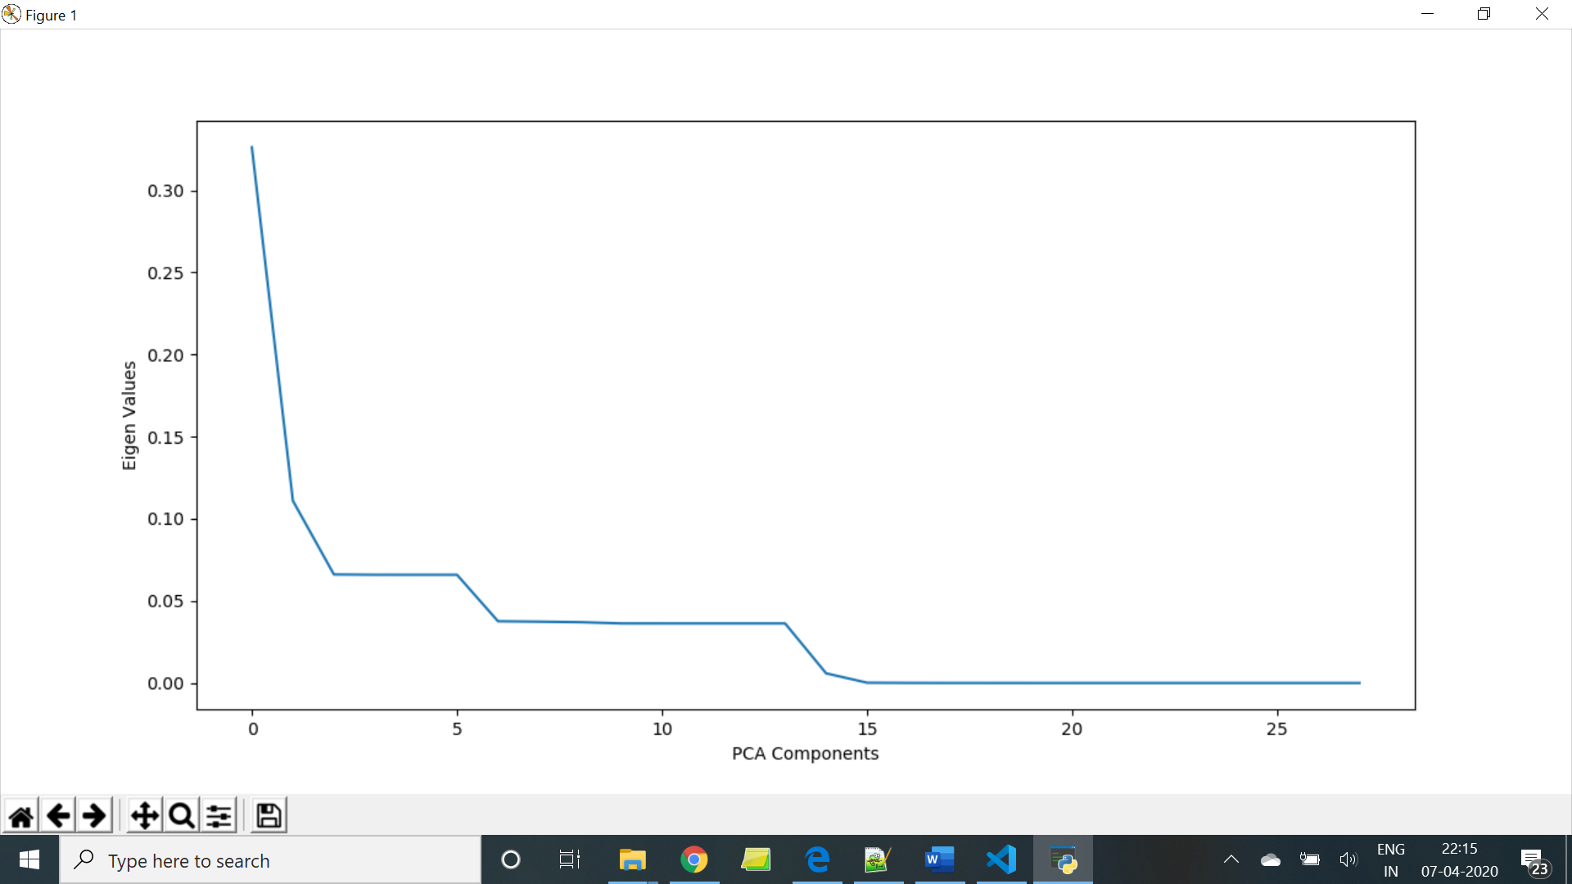

1. **produce scree plot visualization and mark the intrinsic dimensionality**

**For original data :**

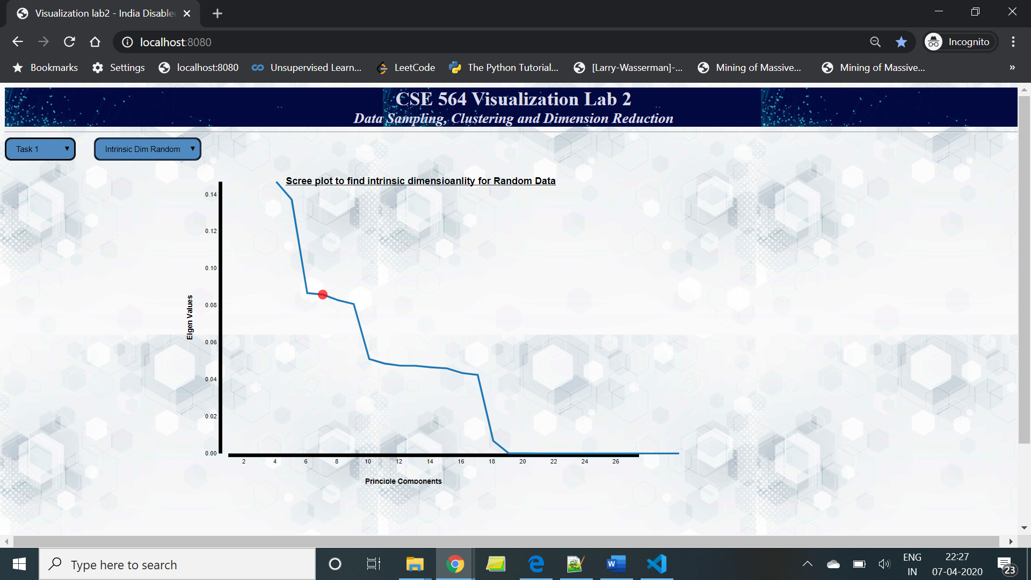

**For Random data:**

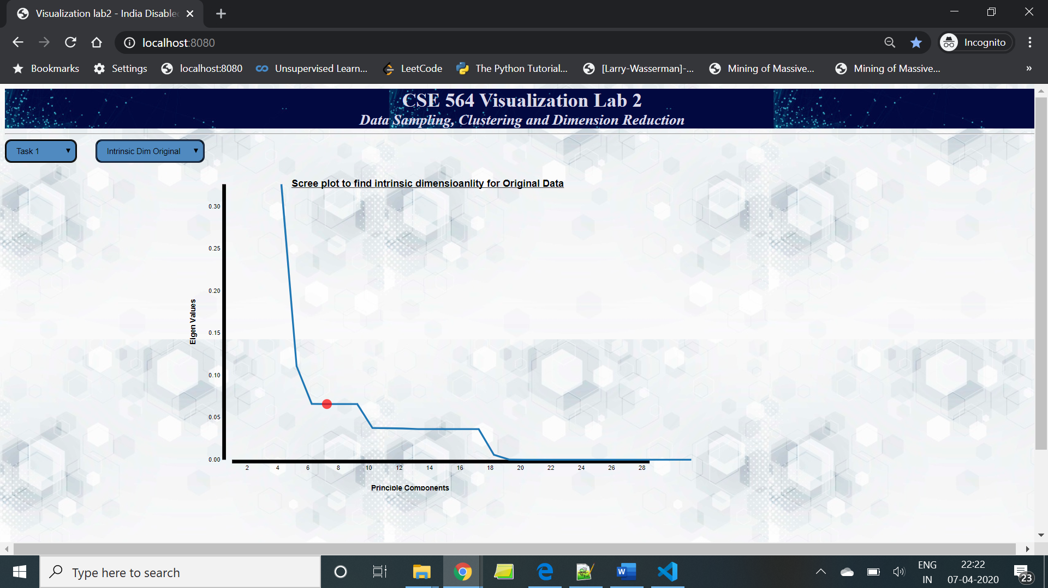

**For Stratified Data:**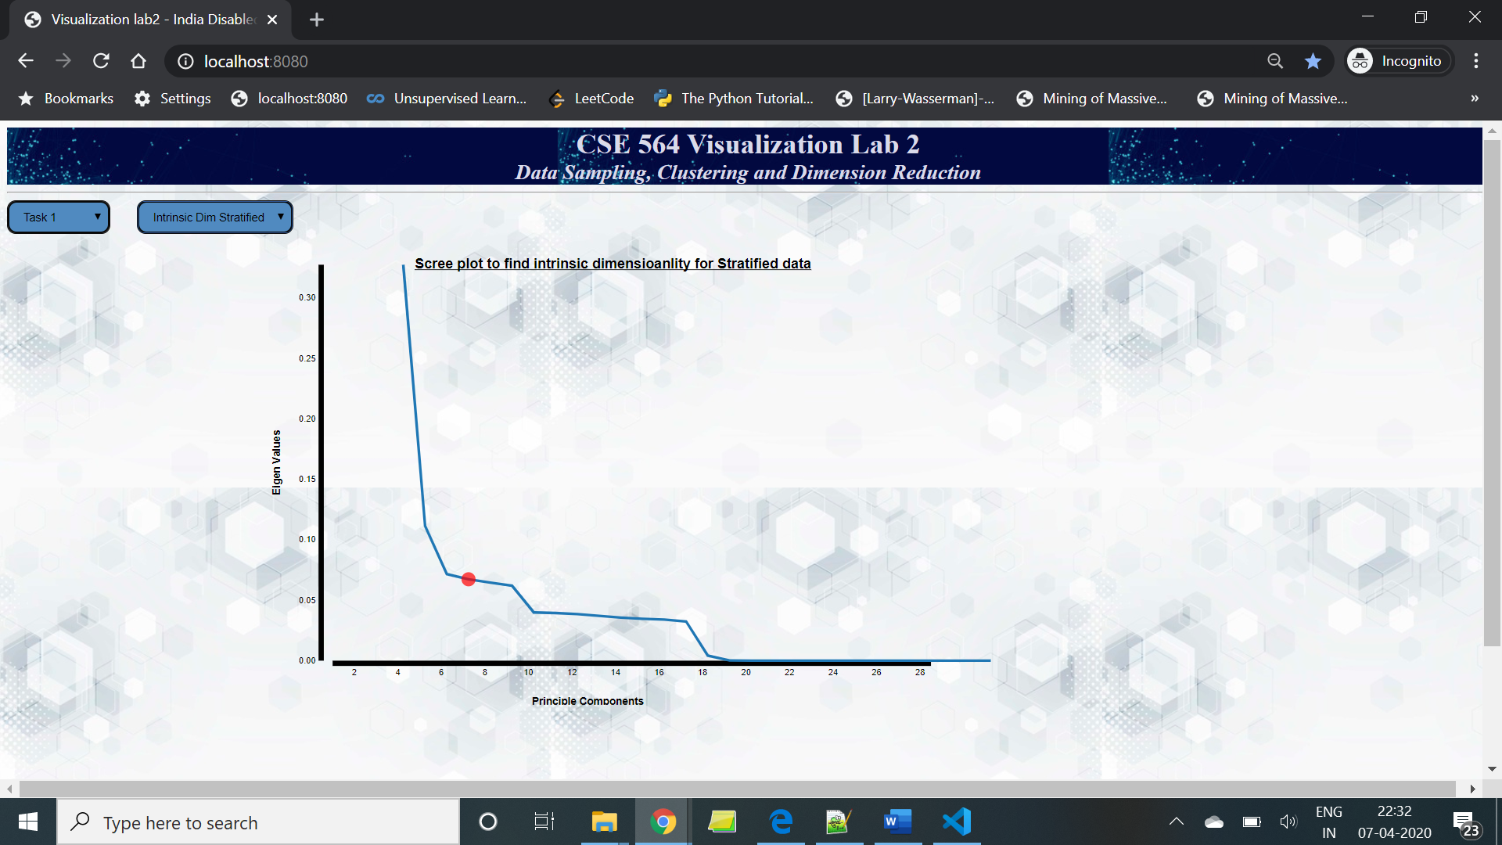

1. **show the scree plots before/after sampling to assess the bias introduced:**

Plot Scree plot to show the explained variance of the PCA components of our data. And in all of the below data samples we can see for PCA component = 8 we have more than 75% explained variance.

**For Original Data -**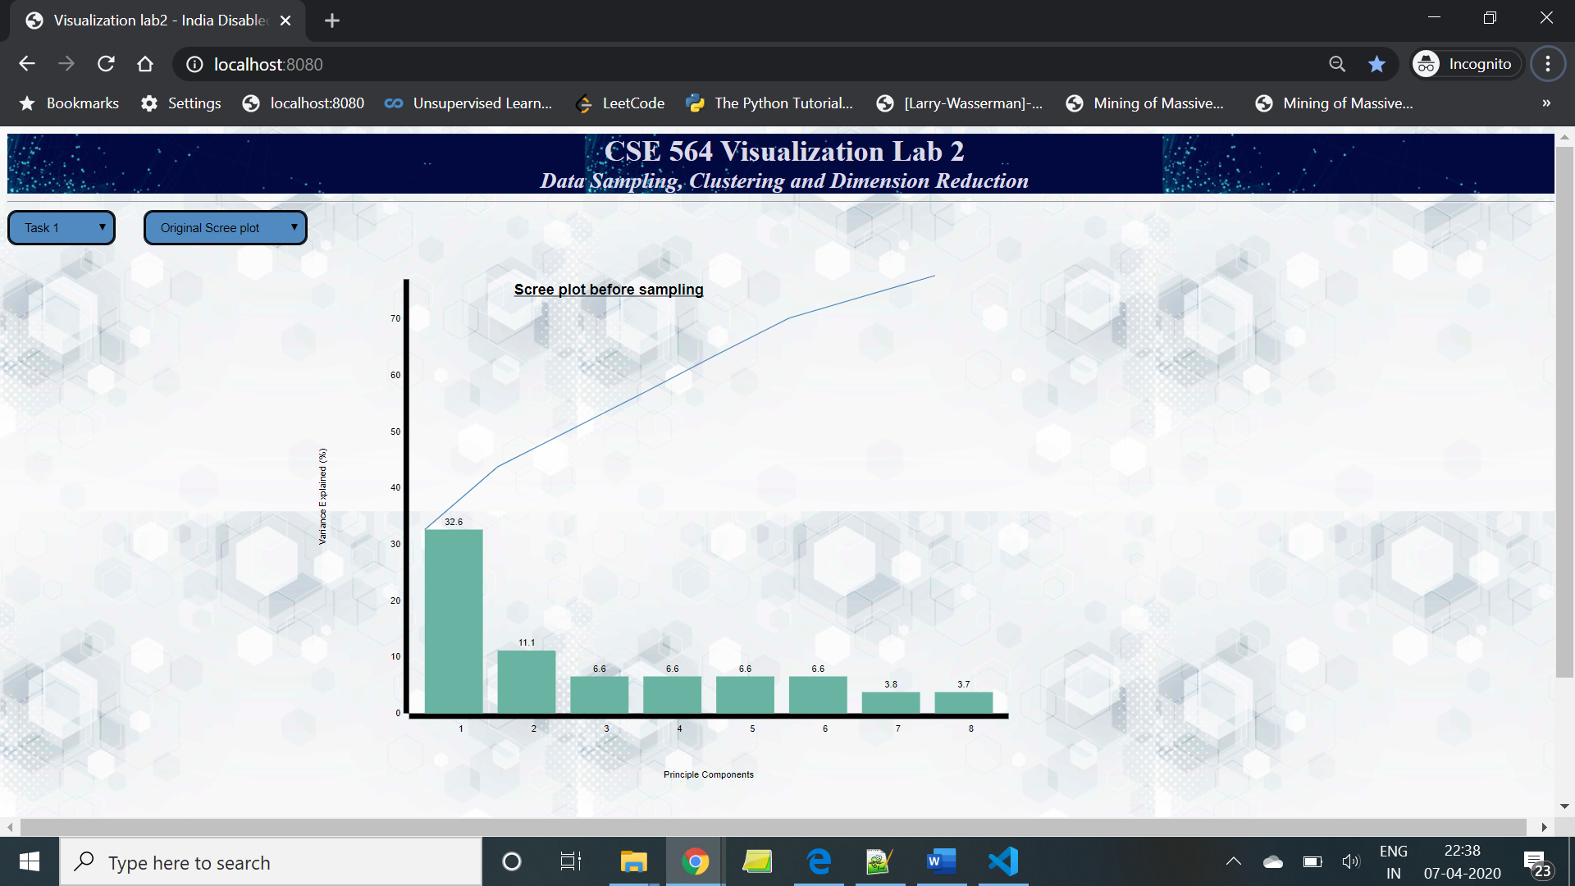

**For Random Sampled Data-**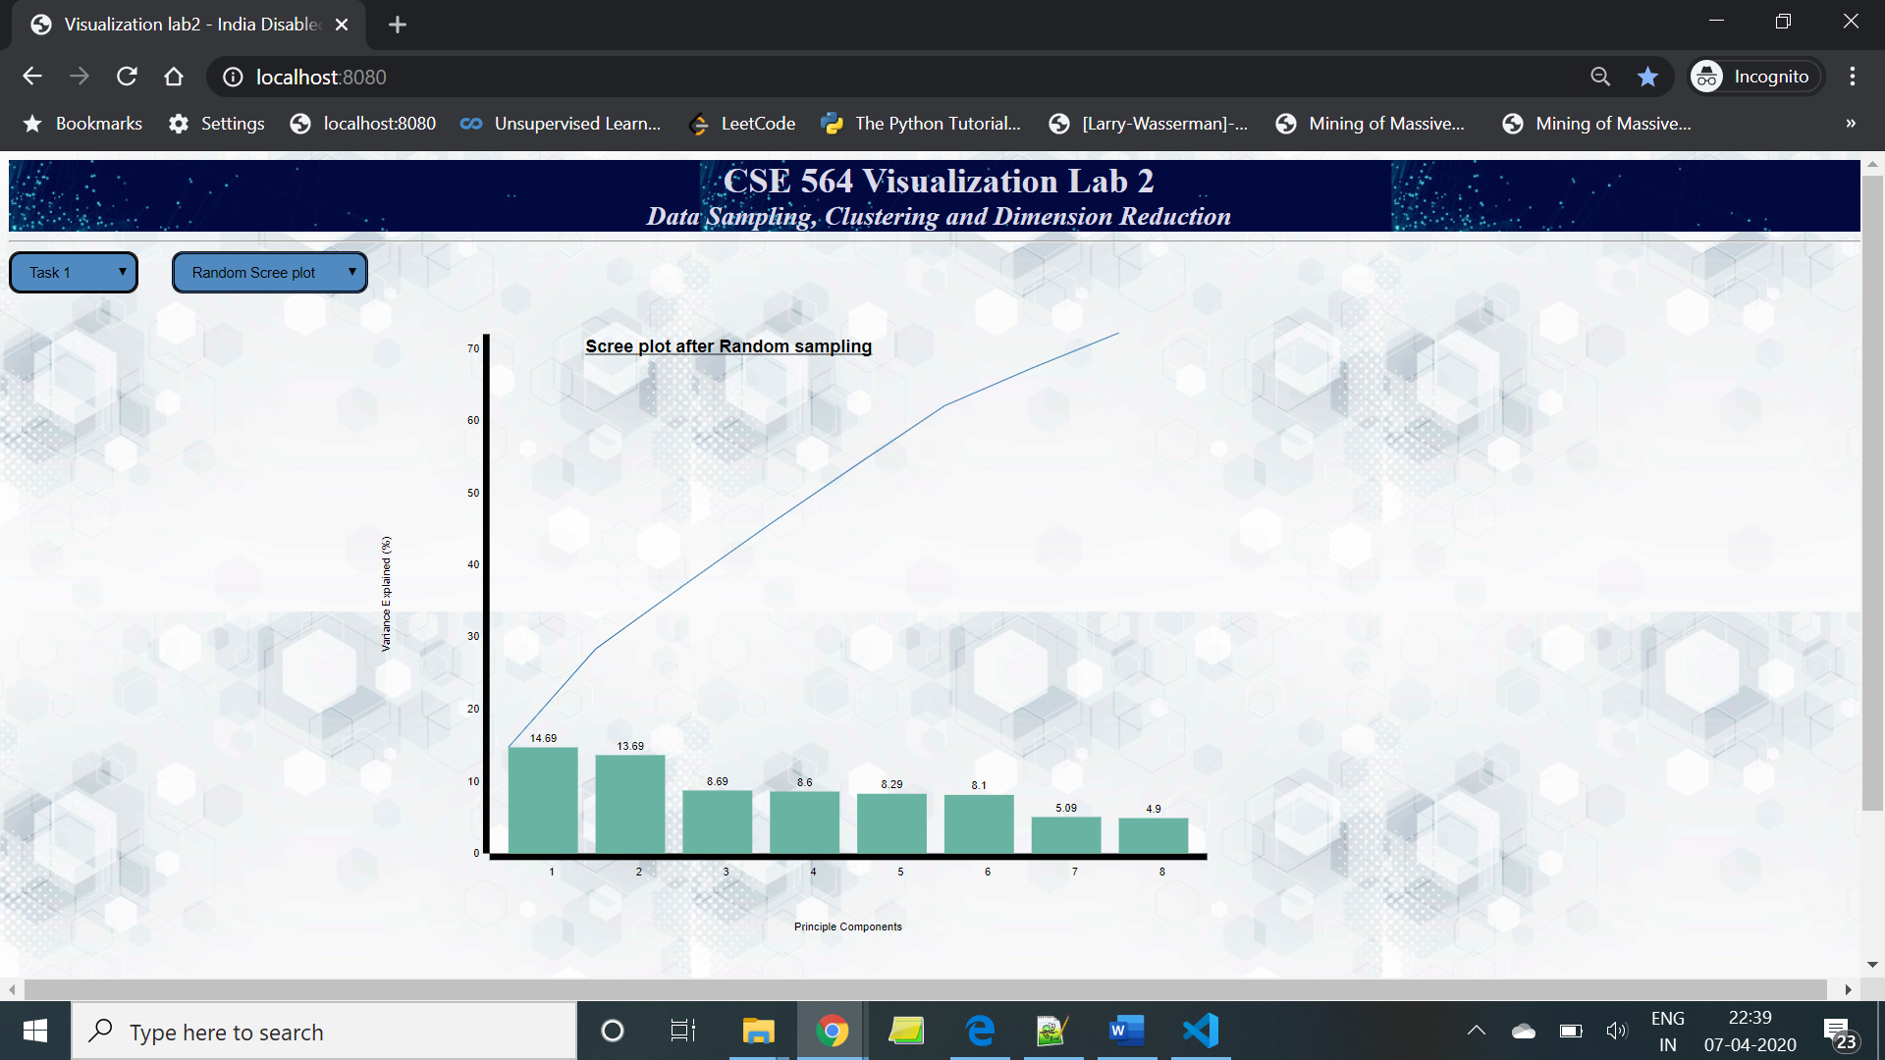

**For Stratified data-**

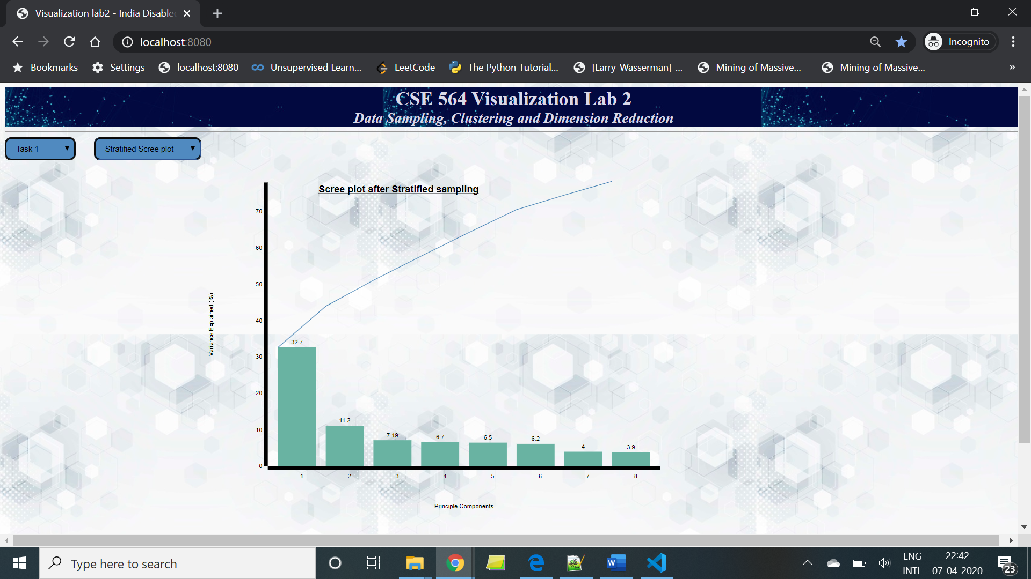

1. **obtain the three attributes with highest PCA loadings**

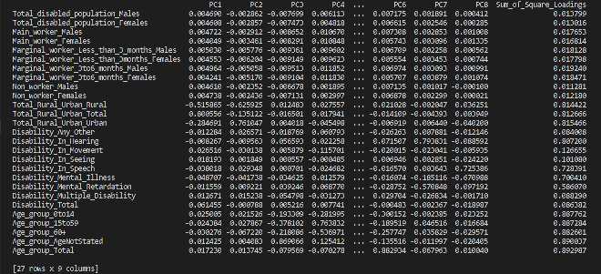

The table above is the values for PC1, PC2, PC3, …. , PC8 and Sum of Square Loadings for all features and it is for Random data. Likewise, it has been calculated for Original and Stratified data. And we can find out the top three attributes of my data from the table that are categorical variables namely, Age_group_15to59, Age_group_60+, Age_group_Total .

**Task 3: visualization of both original and 2 types of reduced data (40 points)**

1. **visualize the data projected into the top two PCA vectors via 2D scatterplot**

**For Original, Random and Stratrified data-** 

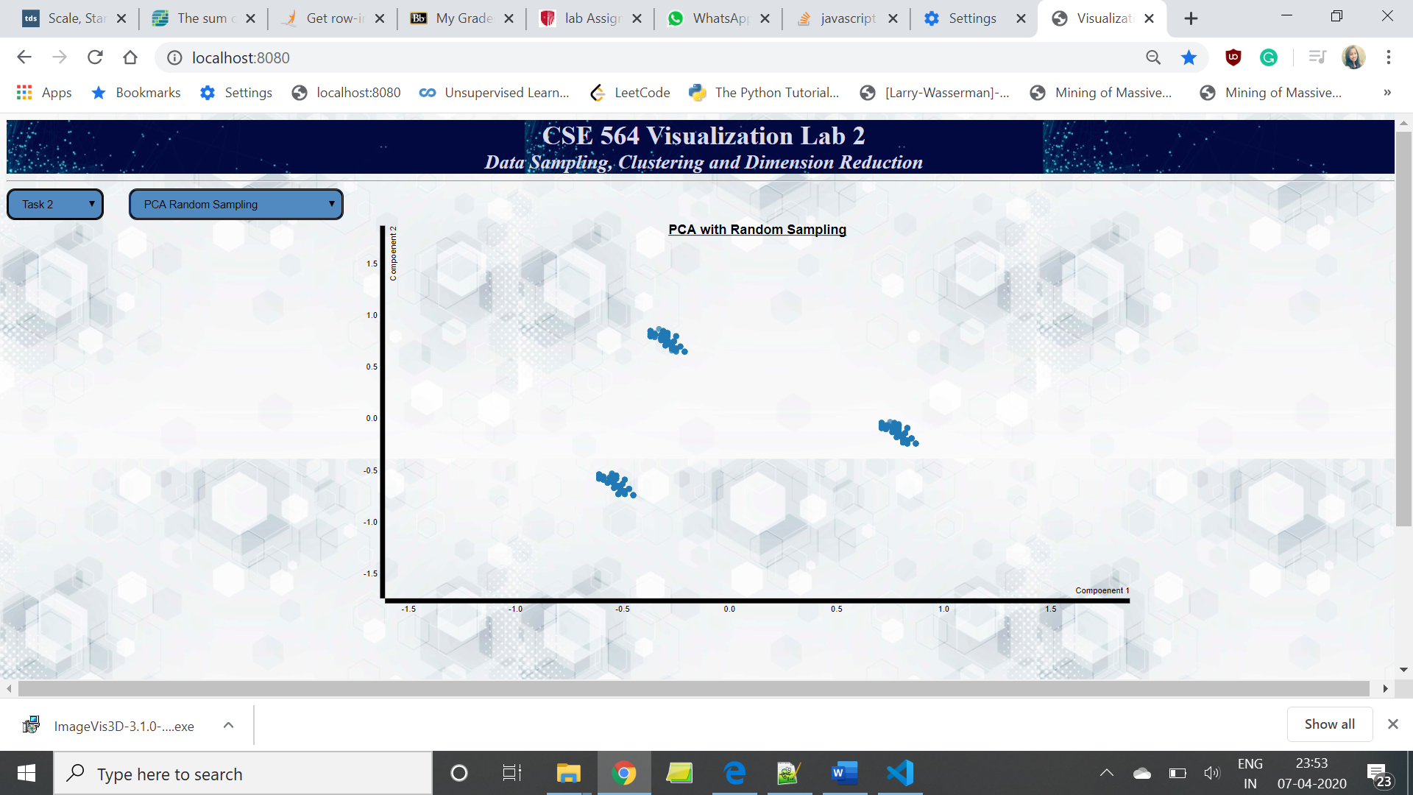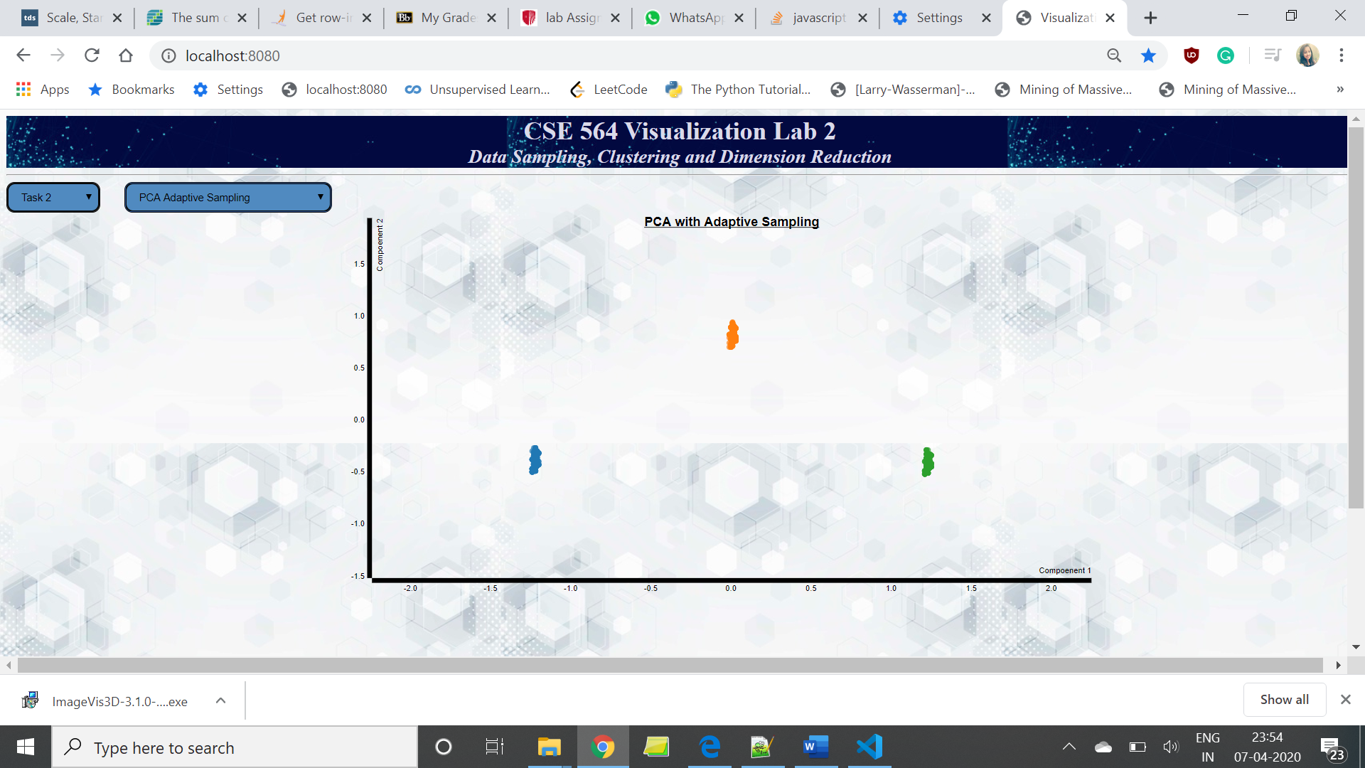

1. **visualize the data via MDS (Euclidian & correlation distance) in 2D scatterplots**

**Euclidian**

**For Original, Random and Stratrified data-**

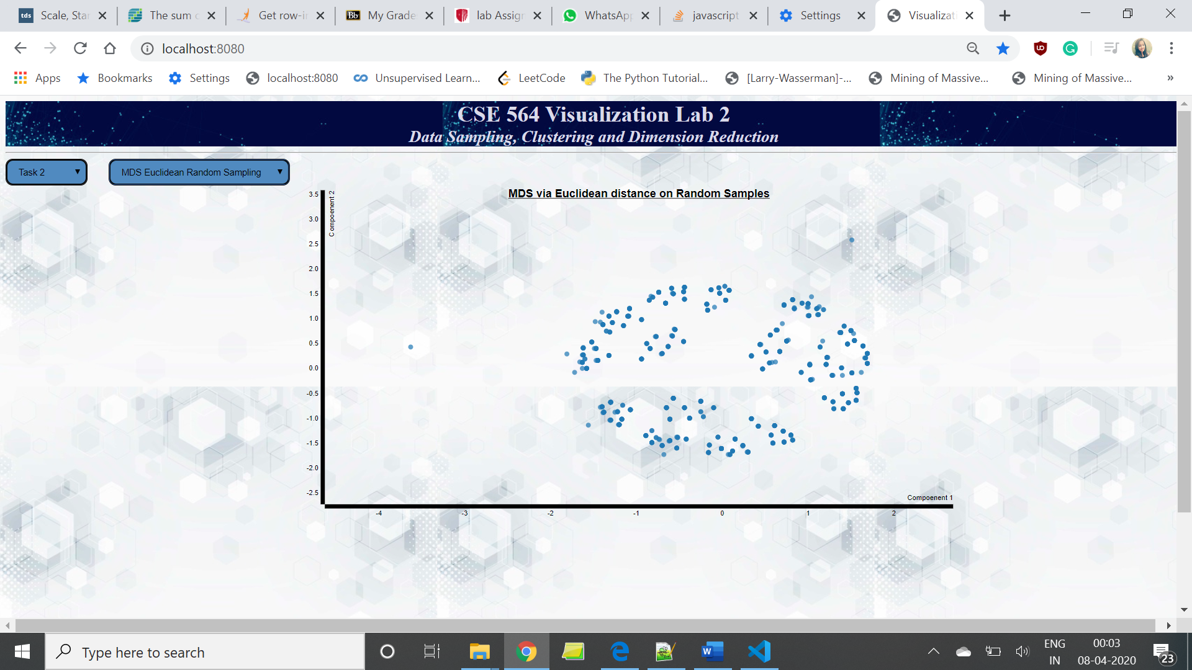

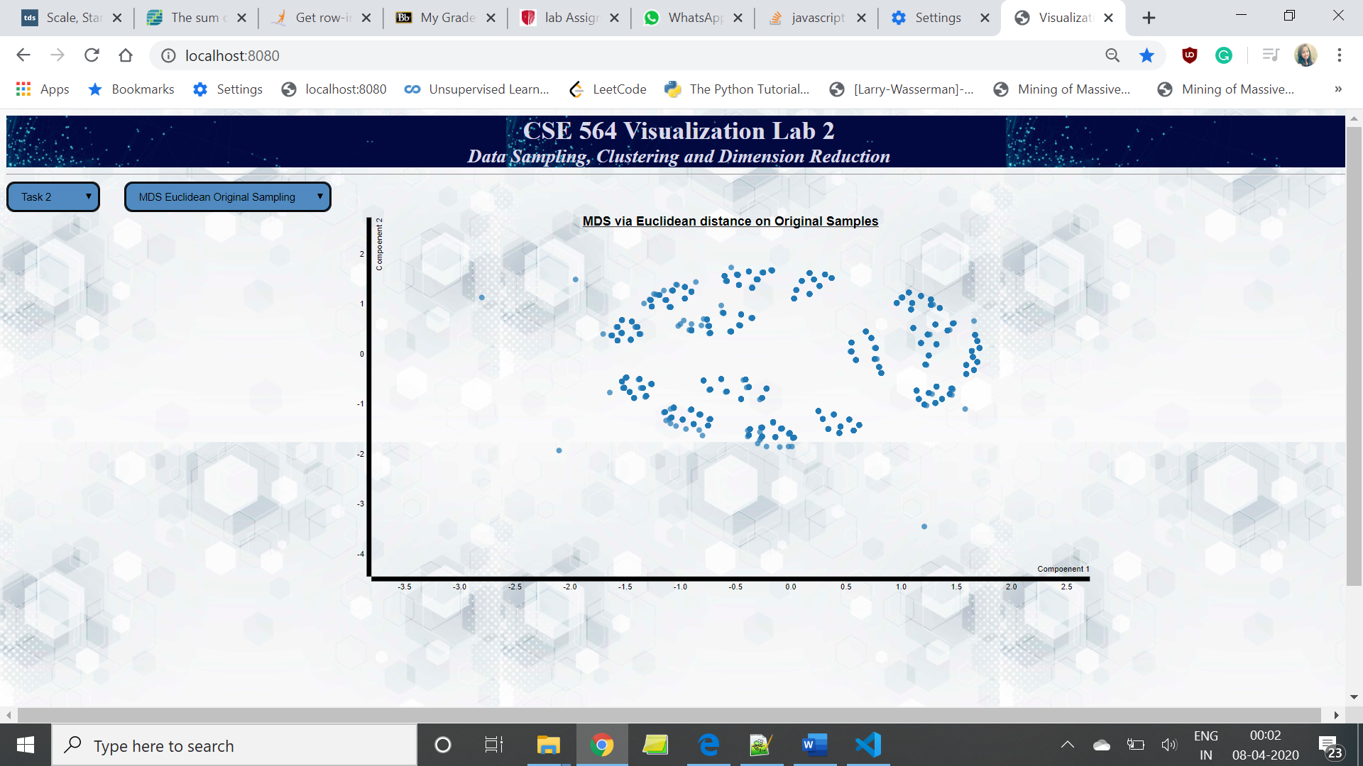

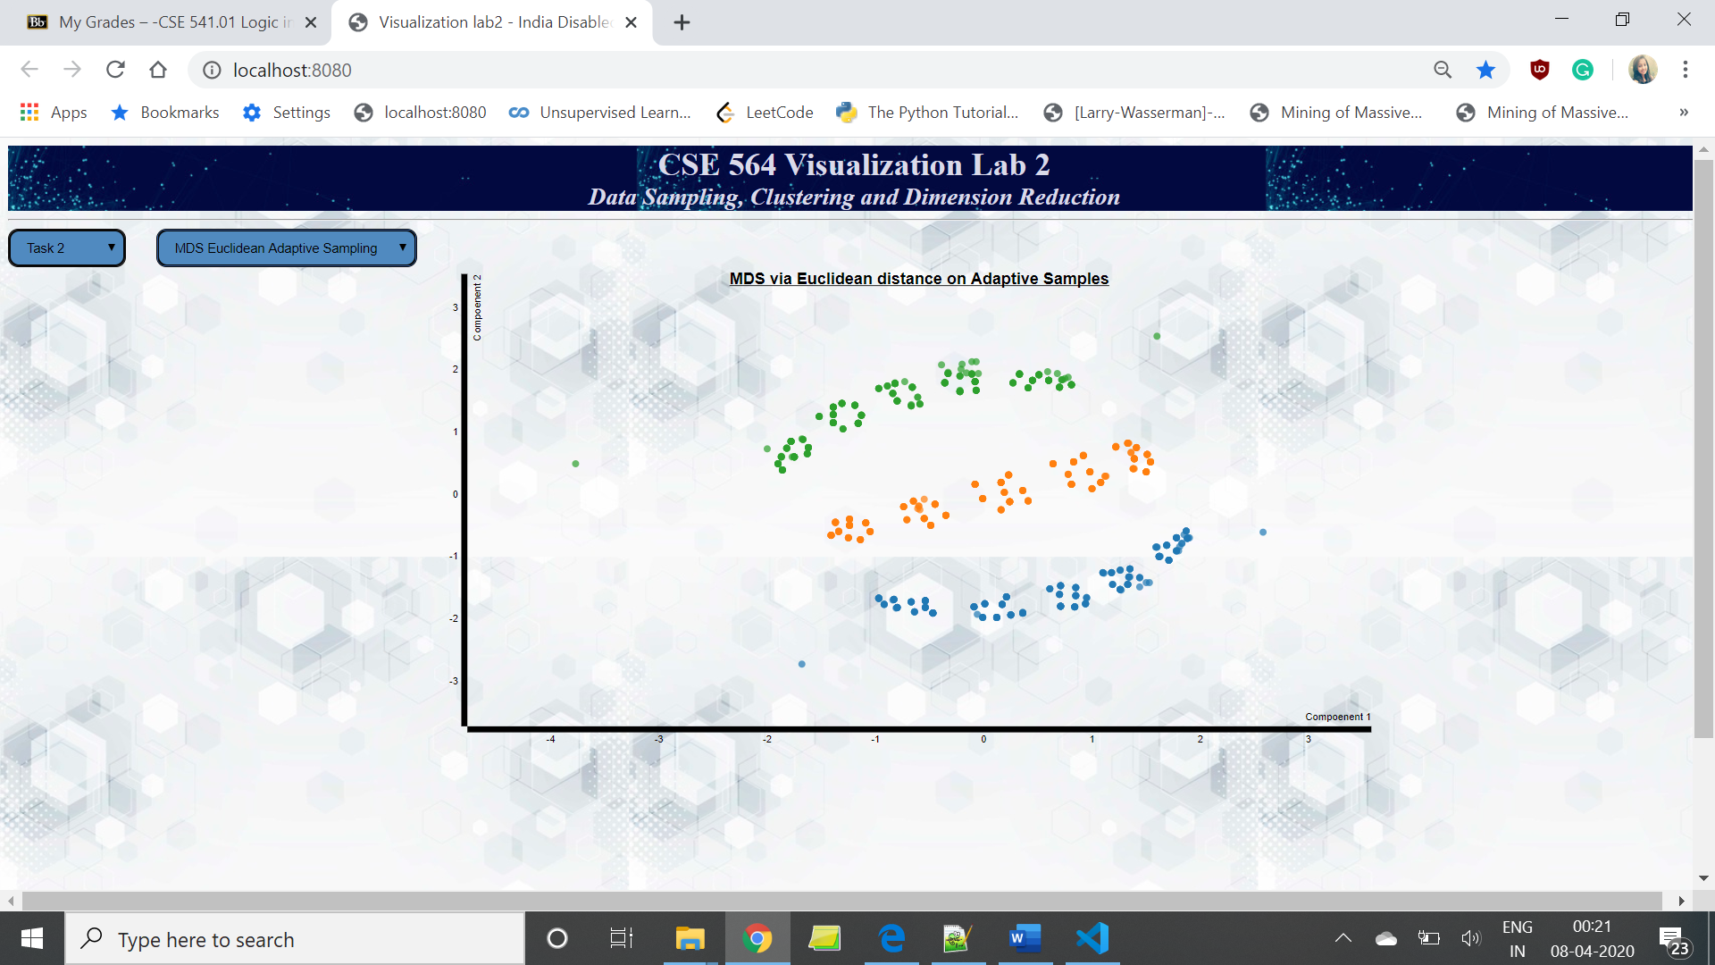

**Correlation  
For Original, Random and Stratrified data-**

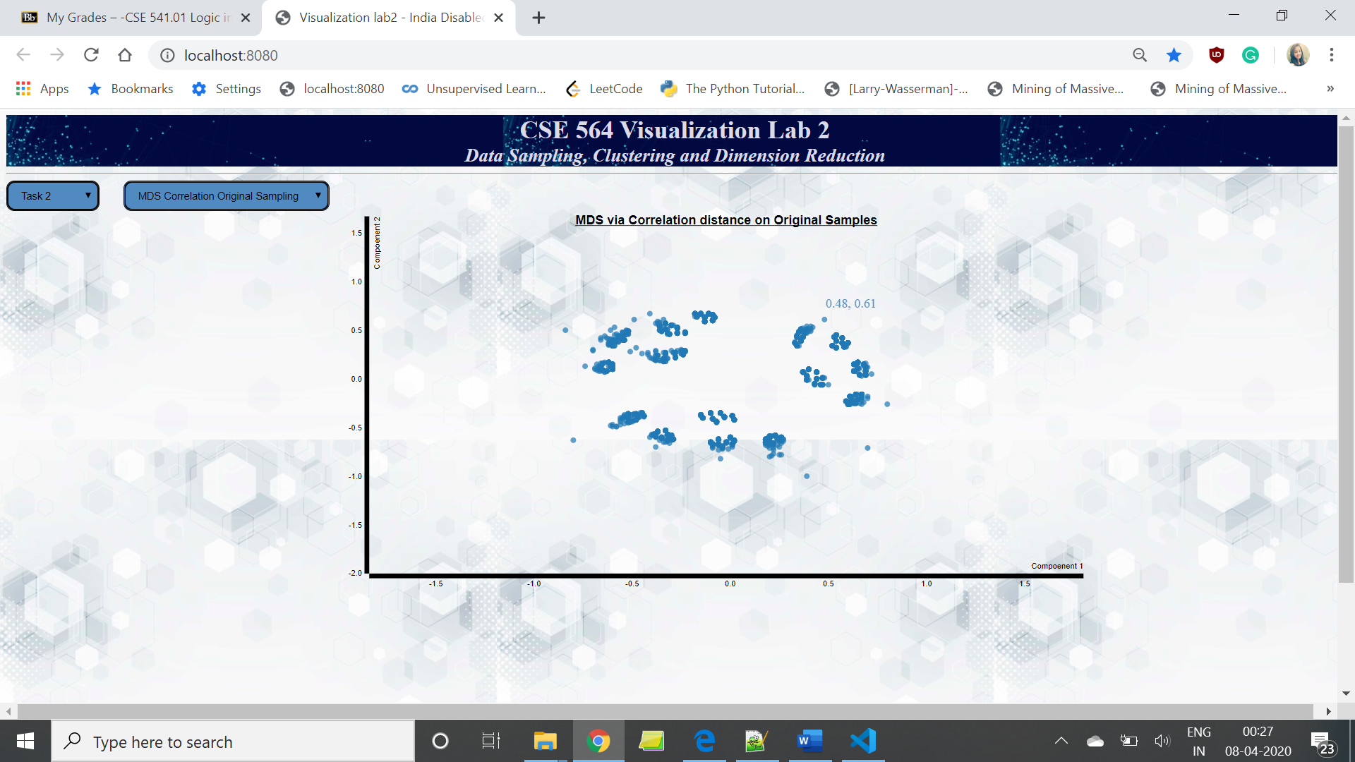

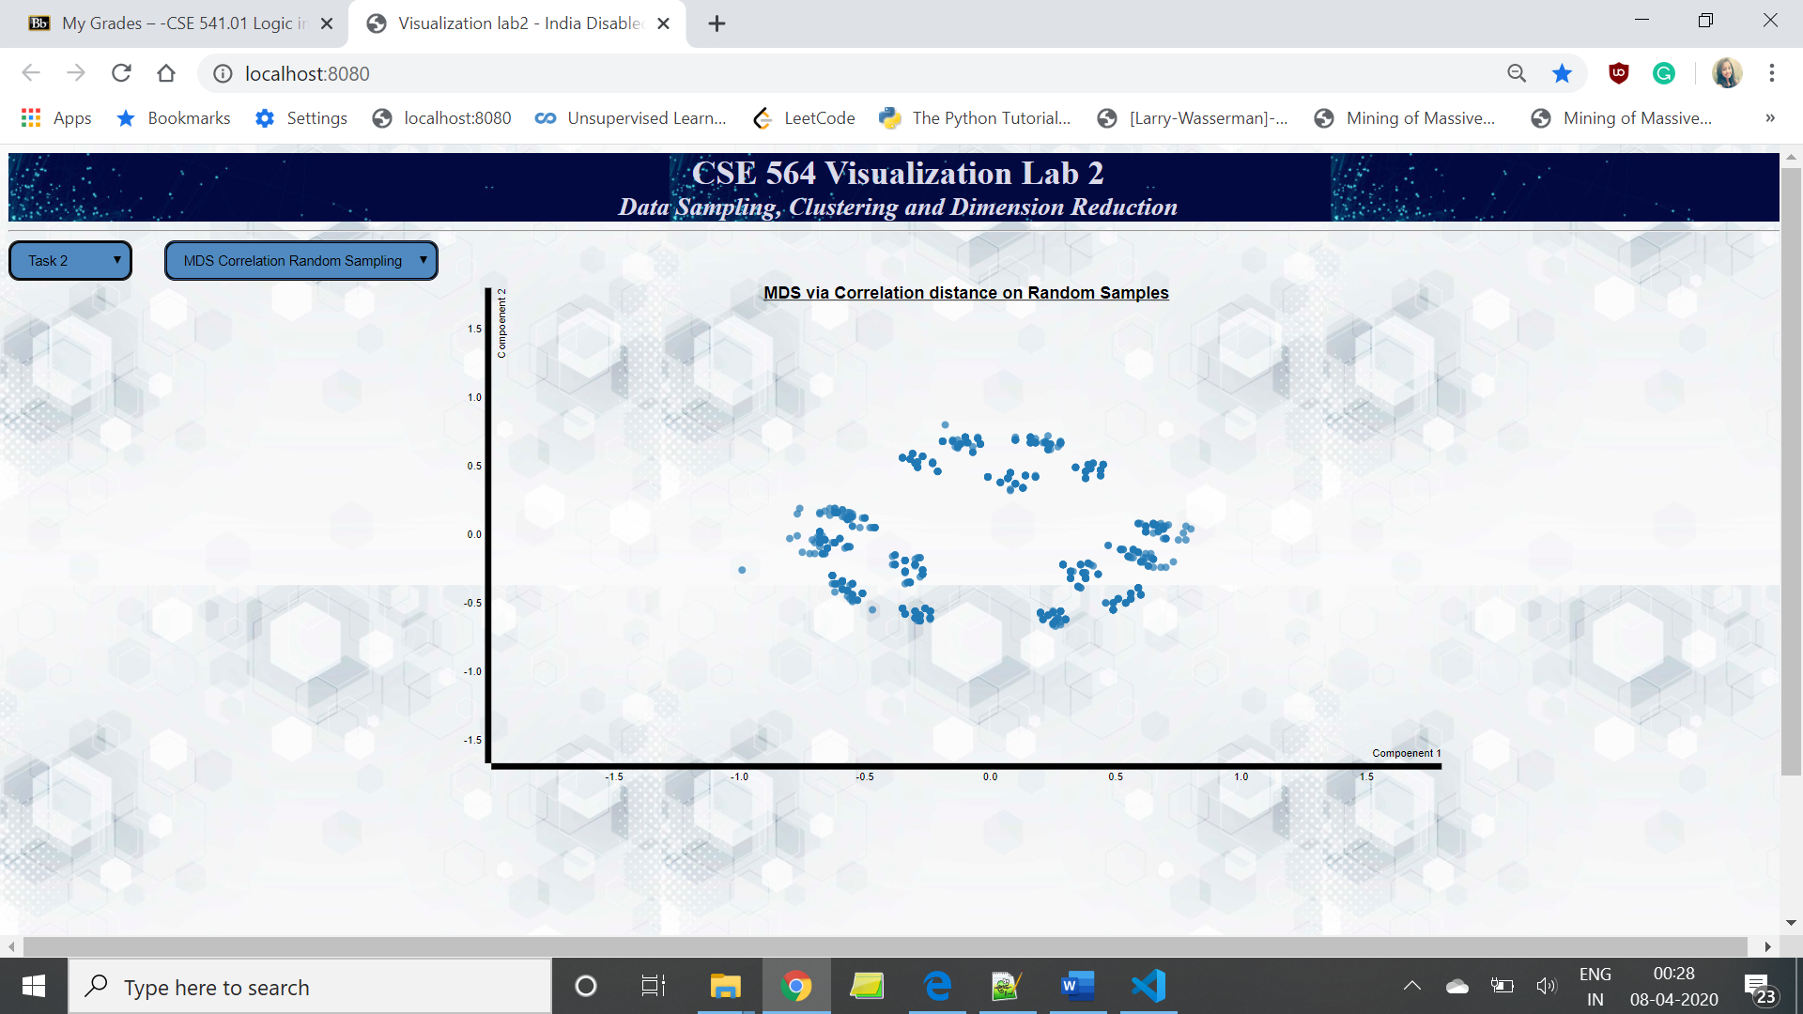

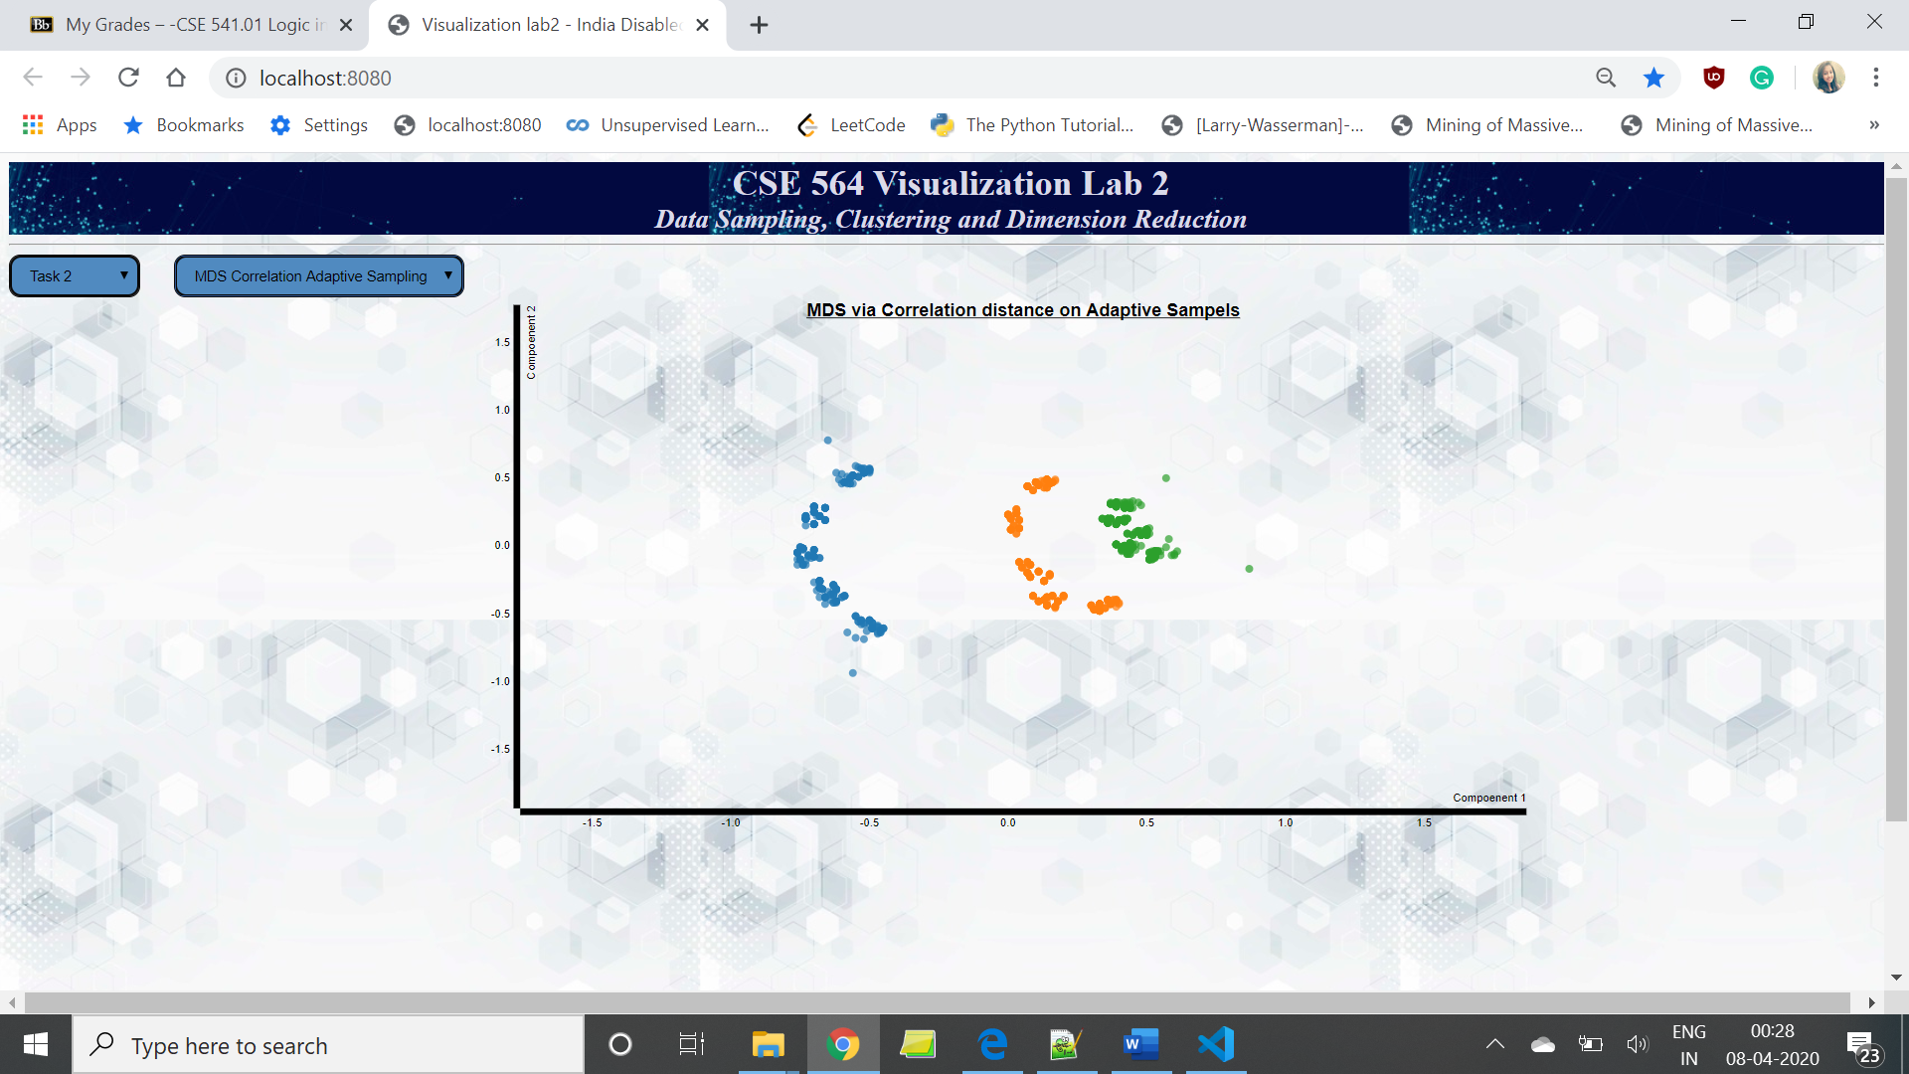

1. **visualize the scatterplot matrix of the three highest PCA loaded attributes**

**For Original and Random data set, it is coming same-**



**And for stratified sample:**

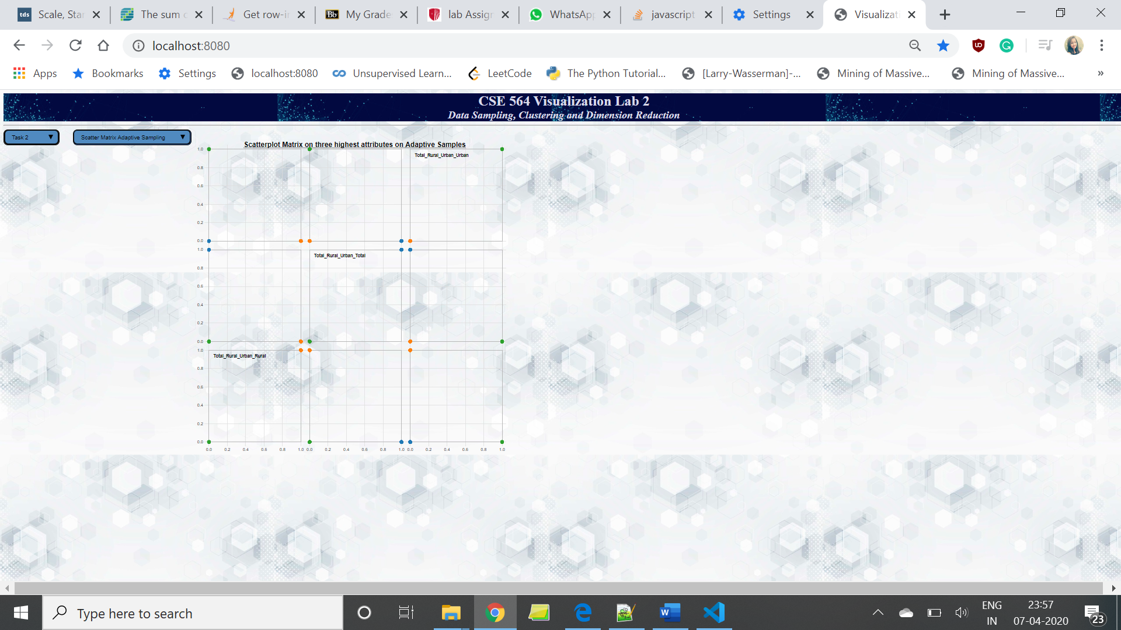

**Since my top three attributes are categorical, they have only two discrete data points. To show that my scatter plot is working, I am choosing top three numerical variables for my report.**

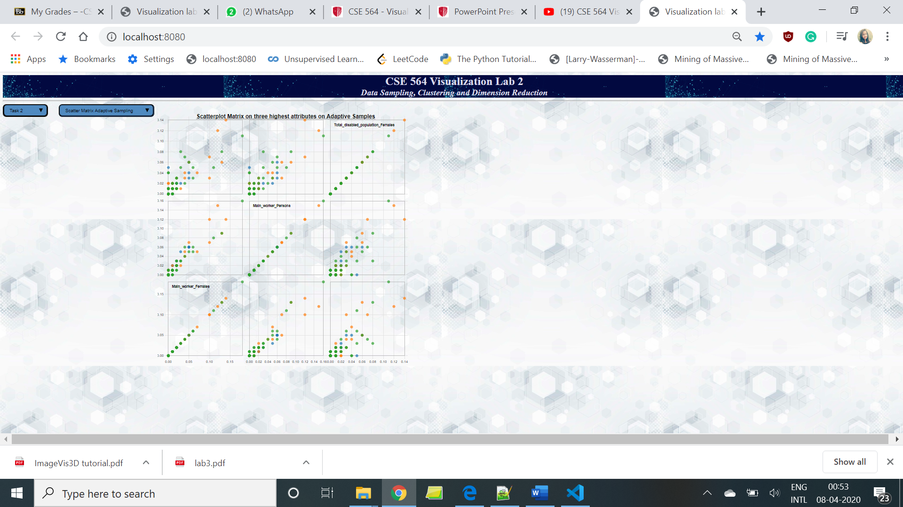

**THANK YOU !!**